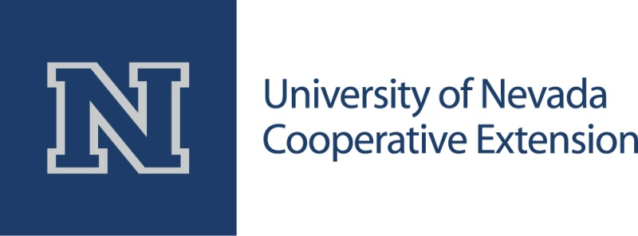

**For immediate release: Dec. 15, 2015**

**Learn how to reduce the radon health risk**

*University of Nevada Cooperative Extension offers free test kits at public meetings statewide*

RENO, Nev. – January is National Radon Action Month, and University of Nevada Cooperative Extension’s Radon Education Program is offering educational presentations at various locations across the state. Free test kits will also be available at the presentations.

Radon is a naturally occurring, radioactive gas that is colorless, odorless and tasteless. It comes from the ground and can accumulate in homes, raising the risk of lung cancer. The U.S. Environmental Protection Agency (EPA) estimates 21,000 Americans die each year from radon-caused lung cancer, killing more people than secondhand smoke, drunk driving, falls in the home, drowning or house fires.

In Nevada, one in four homes tested show radon concentrations at or above the EPA action level. According to experts, living in a home with radon concentrations at the action level poses as much risk of developing lung cancer as smoking about half a pack of cigarettes a day.

The risk of radon-caused lung cancer can be reduced. A simple three-day test can determine if a house has a radon problem, and winter is an ideal time to test a home for radon. If radon problems are found, they can be fixed. Find out more and get a free test kit at a presentation in your community:

Scheduled presentations for Reno, Carson City, Incline Village, Stateline and Minden are:

* Jan. 9 – North Valleys Library, 1075 N. Hills Blvd. #340, Reno, at 11 a.m.
* Jan. 12 – Sierra View Library, 4001 S. Virginia St., Reno, at 4 p.m.
* Jan. 13 – South Valleys Library, 15650A Wedge Parkway, Reno, at 6 p.m.
* Jan. 20 – Northwest Reno Library, 2325 Robb Drive, Reno, at 5:30 p.m.
* Jan. 25 – Carson City Senior Center, 901 Beverly Drive, Carson City, at 6 p.m.
* Jan. 26 – Tahoe Regional Planning Agency, 128 Market St., Stateline, at 6 p.m.
* Jan. 27 – CVIC Hall, 1604 Esmeralda Ave., Minden, at 6 p.m.
* Jan. 28 – Incline Village GID Public Works, 1220 Sweetwater Road, Incline Village, at 6 p.m.

Scheduled presentations for Las Vegas are:

* Jan. 30 – Centennial Hills Library, 6711 N. Buffalo Drive, at 10:30 a.m.
* Jan. 30 – Clark County Library, 1401 E. Flamingo Road, at 2 p.m.
* Jan. 31 – West Charleston Library, 6301 W. Charleston Blvd., at 10:30 a.m.
* Jan. 31 – Sunrise Library, 5400 E. Harris Ave., at 1:30 p.m.
* Feb. 1 – Rainbow Library, 3150 N. Buffalo Drive, at 6 p.m.

Scheduled presentations in other communities are:

* Jan. 7 – Elko County Library, 720 Court St., Elko, at noon
* Jan. 14 – locations in Lyon County
  + Dayton Valley Branch Library, 321 Old Dayton Valley Road, Dayton, 9 to 10 a.m.
  + Fernley Branch Library, 575 Silver Lace Blvd., Fernley, 10:45 to 11:45 a.m.
  + Radon test kits will be distributed at the Park and Ride parking lot at the intersection of Hwy. 95A and Hwy. 50 in Silver Springs, 12:15 to 1:15 p.m.
  + Smith Valley Library, 22 Day Lane, Smith, 3 to 4 p.m.
  + Yerington Central Branch Library, 20 Nevin Way, Yerington, 5 to 6 p.m.
* Feb. 2 – Caliente Fire Hall, next to Rainbow Canyon Motel at 880 Front St. on U.S. 93, Caliente, at 7 p.m.

For those who cannot attend a presentation, free radon test kits are also available through Feb. 29 at University of Nevada Cooperative Extension offices and partner offices statewide.

The Nevada Radon Education Program is a program of University of Nevada Cooperative Extension and is funded by the Nevada Division of Public and Behavioral Health. Since the program began in 2007, more than 21,000 homes have been tested in Nevada.

Cooperative Extension, the EPA and the Nevada Division of Public and Behavioral Health urge all Nevadans to get their homes tested for radon. For more information, visit the Nevada Radon Education Program website at [www.RadonNV.com](http://www.unce.unr.edu/radon), or call the Radon Hotline at 888-RADON10 (888-723-6610).

# # #

**Photo Cutline: Nearly 26 percent of homes tested in Nevada found radon concentrations at or above the EPA action level. For a radon potential map specific to each Nevada county, go to** [**http://www.unce.unr.edu/programs/sites/radon/results/**](http://www.unce.unr.edu/programs/sites/radon/results/)**.**

*University of Nevada Cooperative Extension is the College of the University of Nevada, Reno that is engaged in every Nevada county, presenting research-based knowledge to address critical community needs. It is a county-state-federal partnership providing practical education to people, businesses and communities. For more information on its programs, visit* [*www.unce.unr.edu*](http://www.unce.unr.edu)*.*

Nevada’s land-grant university founded in 1874, the University of Nevada, Reno ranks in the top tier of best national universities by U.S. News and World Report and is steadily growing in enrollment, excellence and reputation. The University serves nearly 21,000 students. Part of the Nevada System of Higher Education, the University is home to the University of Nevada School of Medicine, University of Nevada Cooperative Extension and Wolf Pack Athletics. Through a commitment to world-improving research, student success and outreach benefiting the communities and businesses of Nevada, the University has impact across the state and around the world. For more information, visit [*www.unr.edu*](http://www.unr.edu).

**Contact: Tiffany Kozsan**  
Communications Assistant  
University of Nevada Cooperative Extension  
Dean and Director’s Office  
University of Nevada, Reno / MS 404  
Reno, Nevada 89557-0404  
[kozsant@unce.unr.edu](mailto:kozsant@unce.unr.edu)  
775-784-7072  
[www.unce.unr.edu](http://www.unce.unr.edu)