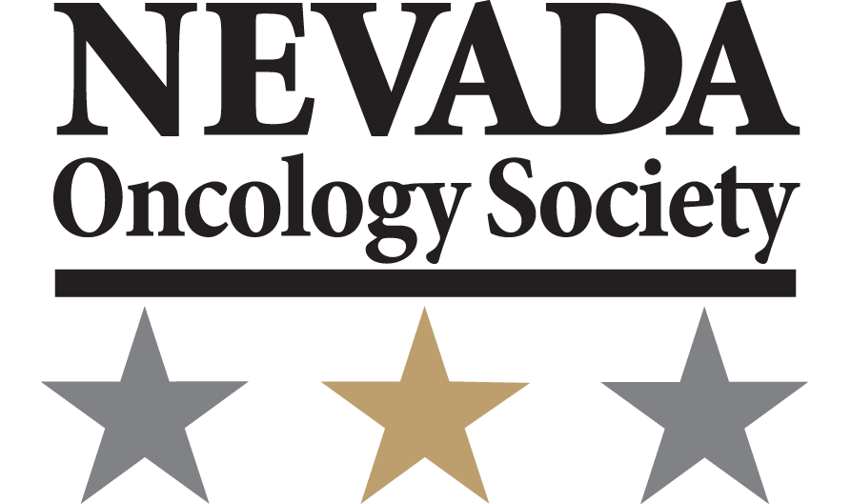

Spring Conference
May 5, 2016
M Resort Las Vegas-Henderson, NV
New Directions in Cancer Management
Agenda

5:30 pm – 6:30 pm Registration & Reception

6:30 pm – 6:45 pm Welcome, Introductions & Dinner
Tejvir Singh, MD
President, Nevada Oncology Society

6:45 pm – 7:30 pm Medicare Update
Arthur Lurvey, MD, FACP, FACE
Noridian Healthcare Solutions

7:30 pm – 7:45 pm Oncology Research Award Winner
Resident TBD
University of Nevada, Las Vegas

7:45 pm – 8:30 pm Progress in Lung Cancer Treatments
David Ross Camidge, MD, PhD
University of Colorado

Agenda Subject to Change

